GTC Scotland Reflective Notebook

Becoming, Being & Growing

Supporting your Professional Learning
The resource is designed for you as an individual or/and to facilitate discussion with your colleagues. Please use the following reflective notebook and supporting to explore and record your reflections.
Remember you can save this reflective notebook as part of your professional learning record through MyPL as shown below.
MyPL can be accessed through MyGTCS by clicking here.
This workbook is designed to be used alongside the accompanying PowerPoint. Both have been split into 4 parts for ease of use.
SLIDE 2
PART 1 | Taking ownership and bringing the Professional Standards to life
PART 2 | Explore the inter-connections between the Professional Standards and teacher professionalism as central to Professional Update
PART 3 | Explore your Professional Learning focus and the Professional Standards
PART 4 | Consider next steps for your own professional learning; using the Professional Standards to support this journey

SLIDE 3
The resource is designed for you as an individual or/and to facilitate discussion with your colleagues.
Please use the reflective notebook and supporting slides to explore and record your reflections.
Please remember you can save the reflective notebook as part of your professional learning record.
Click here to access MyGTCS to upload an entry to your professional learning record

PART ONE - (SLIDES 4-11)
Taking ownership and bringing the Professional Standards to life
Activity 1 (Slide 6) - Professional Standards Self-evaluation wheel
Using a self-evaluation wheel
Take a few minutes to complete your wheel. Consider each point and think about where you might gauge yourself on it and mark the number that matches your thoughts with a dot:
0 = really not confident/unfamiliar with this/lots of areas to develop or work om;
10 = feel very confident/accomplished in this area
Think about ‘why’ you placed yourself on that point of the scale. You may wish to make some reflective notes. Look across your wheel and use the following questions to explore your thinking. It can be helpful to do this with a colleague to share the professional dialogue.
- What do you notice? What stands out?
- What are key strengths?
- What is most important here?
- Any big questions emerging?
- What area(s) would you like to focus on?
  - What is working well here?
  - Where would you like to be in June/3 months’ time?
  - What is your action plan/next steps?
  - Who and what can support you?

Tools to support self-evaluation - The General Teaching Council for Scotland (gtcs.org.uk)

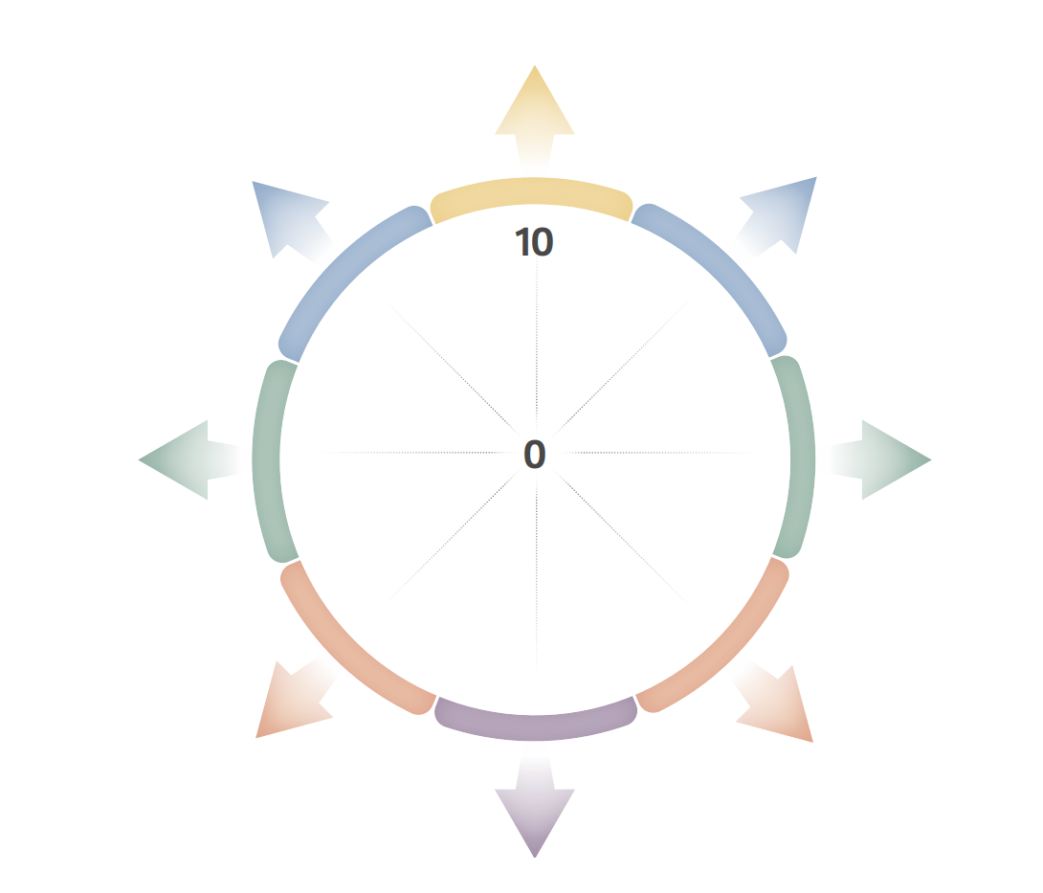
I am confident moving across and between the Professional Standards as developmental frameworks
I know which aspects of the Professional Standards link to my current role and aspirations
I maintain a reflective record of professional learning and evidence of its impact on my thinking and professional actions linked to the Professional Standards
I use the Professional Standards to critically examine my attitudes, beliefs and values in action
I use the Professional Standards to explore areas of interest for my professional learning
I use the Professional Standards to identify and build upon areas of strength and for development
I use the Professional Standards to reflect on the impact of my professional learning on my own professional development
I use the Professional Standards to support my professional learning in meaningful ways and discuss this as part of my PRD
PART ONE
ACTIVITY ONE – SLIDE SIX
The coaching wheel is used at this stage to baseline your current engagement with the Professional Standards and create purpose for using this resource. After deepening your understanding through this resource, you may find it helpful to come back to this activity at the end to re-evaluate.

Click here to access further tools to support self-evaluation

PART TWO - (SLIDES 12-17)
Teacher Professionalism

Activity 2 – True or false Professional Update (SLIDE 14)
True or false – Professional Update is ….
- the way teachers in Scotland maintain their professional registration

- based on a teacher's ongoing engagement in professional learning

- led by the teacher’s self-evaluation and reflection using
the Professional Standards

- supported by ongoing dialogue through a
Professional Review and Development system

- supported by maintaining a set number of records of
professional learning

- based on practitioner enquiry

- signed off every 5 years

Reflections and notes

Activity 3 (SLIDE 16) – Professional Standards as a key feature in the national model of professional learning:
Look at the ways the Professional Standards both support and inform professional learning as set out in the national model of professional learning.

Consider and discuss the ways you use the Professional Standards, or ways you would like to explore further, to affirm and support your professional learning:

- To self-evaluate and engage in critically reflective thinking about practice as part of regular, planned and ongoing professional learning dialogues and development
- To support professional growth and agency
- To ask critical questions of self, school or organisation and system
- As a catalyst for learning
- To frame and support thinking and practice
- As a way to signpost and plan learning
- To challenge and consider beliefs, values and professional actions
- To explore professional identity

Reflections and notes

PART THREE - (SLIDES 18-21)
Your Professional Learning Focus and the Professional Standards

Activity 4 - Professional Learning ‘Why?’ (SLIDE 19)
This activity helps draw connections between professional learning and prepares for the following task on using the Professional Standards. It is based on the work of Simon Sinek – ‘Start with Why’ and you might like to watch the following 5 minute Ted talk Simon Sinek - start with why.
As an individual, reflect on the 4 statements below and make some notes to capture your thinking (approx. 10 minutes).
Pair up with another colleague and discuss your responses. You may also wish to consider:
- Common themes
- Areas of contrast
- What is important about professional learning for you
- How your professional learning has supported your teaching career

Reflections and notes

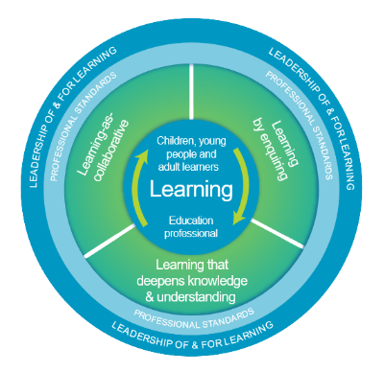
Activity 4 - Professional Learning ‘Why?’
(SLIDE 19)

4.
3.
3.
1.
Activity 5 (SLIDE 19)
Professional Standards and your professional learning focus

The Professional Standards page may be helpful

Which Professional Standard(s) is most relevant to you as a learner?
- Standard for Provisional Registration
- Standard for full Registration
- Standard for Career-long Professional Learning
- Standard for Middle Leadership
- Standard for Headship

In relation to your current professional learning focus ….
Note – refer to activity 4 on slide 19
- Which Professional Standard is most relevant to you as a learner?

- In what ways do the Professional Standards describe your learning focus?

- How can/do the Professional Standards support dialogue about your professional learning?

- How can/do the professional Standards help connect your learning to the impact on self, colleagues and the learners you work with

Reflections and notes

PART FOUR - (SLIDES 22-24)
Taking ownership and bringing the Professional Standards to life

Activity 6 (SLIDE 23)
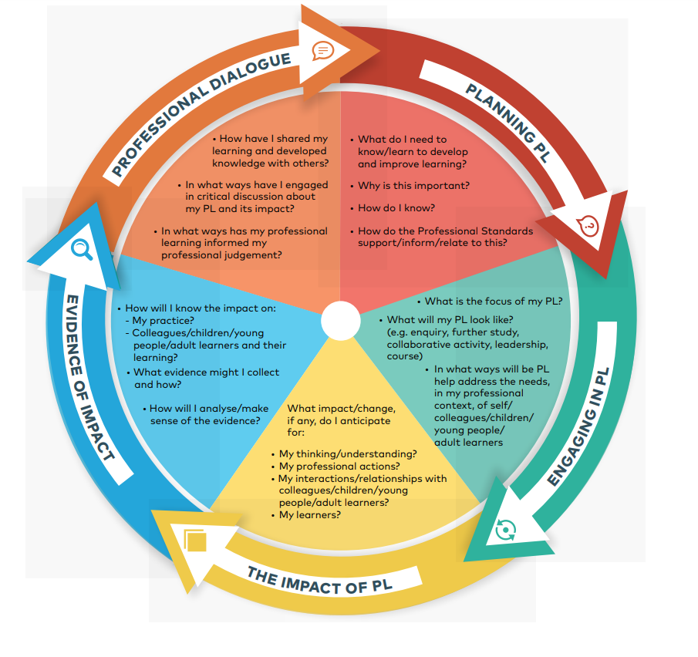
Professional Learning Planning Cycle Next Steps

Professional dialogue – PRD Coaching
Self-evaluation and the Standards

Critically informed practice
Collaborative learning, practitioner enquiry

Reflection on professional thinking and actions

Reflections and notes
- What are your next steps?
- What support would be helpful?

Additional reflections and notes

